Autoresponder not working because messages being routed incorrectly.

See below, keyword 1234 is assigned to accountId35.

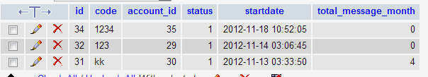

If I send 1234 keyword to the SMS number, it is being assigned to accounted 29 incorrectly…as are all the other messages coming in.

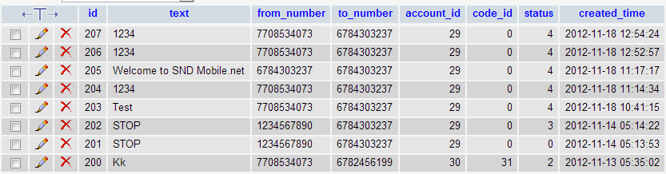

Why are all inbound messages being assigned to account_id 29?

===============================================================================================

Limit control not working

I had 0.5 credits in plan_credits and tried to send single message. This should have been stopped before sending with user error message. Instead, I got fatal error and the message was deliverd.

**Fatal error**: Uncaught exception 'Services_Twilio_RestException' with message 'The 'From' number 8577763669 is not a valid phone number or shortcode.' in /home/content/62/10051662/html/app/libs/twilio/Services/Twilio.php:213 Stack trace: #0 /home/content/62/10051662/html/app/libs/twilio/Services/Twilio.php(185): Services_Twilio->_processResponse(Array) #1 /home/content/62/10051662/html/app/libs/twilio/Services/Twilio/ListResource.php(83): Services_Twilio->createData('/2010-04-01/Acc...', Array) #2 /home/content/62/10051662/html/app/libs/twilio/Services/Twilio/Rest/SmsMessages.php(17): Services_Twilio_ListResource->_create(Array) #3 /home/content/62/10051662/html/app/libs/twilio/sms.php(46): Services_Twilio_Rest_SmsMessages->create('8577763669', '7708534073', '? Accoun...') #4 /home/content/62/10051662/html/app/libs/helper/common.php(357): sendsms(Object(AutoAccount), true, '7708534073', '? Accoun...') #5 /home/content/62/10051662/html/app/libs/twilio/sms.php(88): check_limit_message(Object(AutoAccount)) #6 /h in**/home/content/62/10051662/html/app/libs/twilio/Services/Twilio.php** on line **213**

===================================

I tried same thing with 0 credits and all it did was take me to Sent Messages screen. We need to show a user error when user tries to send with no credits. This was working before when user tried to send with messages left. We need the same thing for no credits left.

======================================================

I did cancel subscription with my account that had shared SMS and it released the Twillio number. This is very bad. If user cancels with account that has shared SMS, then it cannot cancel the twillo number.

The Twillio number it canceled was 6784303237